X-Ray Florescence as a Method of Element Identification

Trygve Ristroph
632-36-8465
February 23, 1999

ABSTRACT

A soft x-ray Cadmium-109 source, a lithium-drifted germanium detector, and a multi-channel analyzer were used to produce a spectrum of the fluoresced x-rays that provided a signature of inner-shell electron energy levels. Characteristic YBCO lines were used to calibrate the system after which ten samples were studied and constituent elements identified. All lines with the exception of one were within error ranges from accepted values.

INTRODUCTION

The inner-electrons of atoms are tightly bound to the nucleus with energies in the one to one hundred keV, or x-ray, range. A x-ray incident on the element can remove one of these electrons. The hole where the electron was, is soon filled by a free electron and the atom returns to the ground state by the rearranging its electrons. Readmission of x-rays accompanies the changes in electron structure. These x-rays occur at discrete energies equal to the change in energies between levels. The collection of these lines gives each element a unique x-ray fingerprint that may used to identify it. Since the inner-electrons are not effected the outer-electrons’ bounding to other atoms, elements may identified regardless of what compounds or solids they may be a part of.

EXPERIMENTAL APPARATUS AND PROCEDURE

The apparatus consisted of a cadmium-109 x-ray source, a liquid nitrogen-cooled detector and pre-amplifier, a spectroscopy amplifier, multi-channel analyzer, and a computer used to view and analyze the spectra. See figure for the general layout of the experiment.
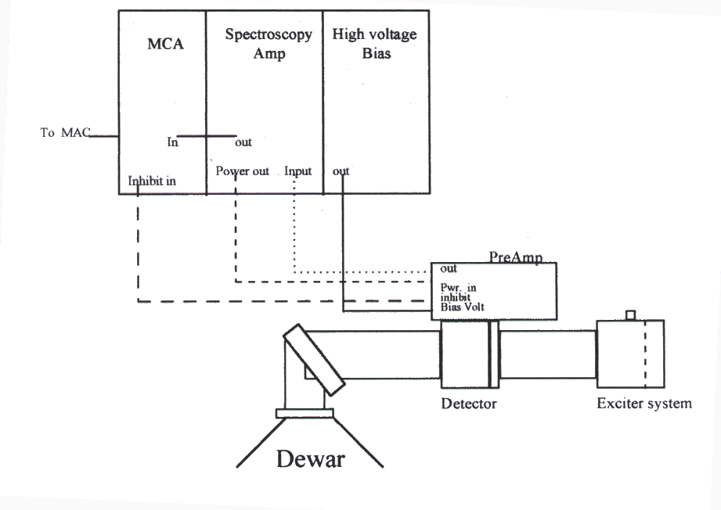
The cadmium source was an annulus of cadmium-109 shielded by tungsten. No lines were observed if the source was oriented in the housing such that the writing was visible. When the writing faced the detector, lines were observed indicating the x-rays are not completely directed towards the center. The source used in this experiment was a 100 $μ$Ci from 1983. Cadmium-109 decays to silver-109 via electron capture according to the reaction
Cd¹⁰⁹ + e⁻ → Ag¹⁰⁹ + γ
where γ is an x-ray with an energy of 88.04 keV. Of course this x-ray causes the cadmium and silver in the source to fluoresce at energies of 22.2, 24.042, 23.172, 26.1 keV for the Ka and Kb lines for silver and cadmium respectively. These lines were apparent all samples, while the 88 keV lines was above the range of the detector. Readmitted x-rays passed through the hole in the source and through an extremely thin and delicate beryllium window and into the detector.
Samples were generally in powered form held intact by tape. Powdered forms of YBCO yielded sufficient spectra while the solid pellet form yielded only noise. Unfortunately many of the samples were stored together in the same box. It appeared that some samples had leaked from the tape holding them together to contaminate other samples. The data would later support this.
Aluminum housing (shown in figure with detector) held the samples, source, and detector. A tungsten disk approximately five millimeters thick prevented x-rays from escaping the housing. This disk and this housing were cleaned periodically with alcohol to prevent contamination of the housing. A dewar filled liquid nitrogen (77K) sat below the housing and a thermal connection was formed by a metal rod. The dewar was filled each morning and allowed to cool the specified four hours.
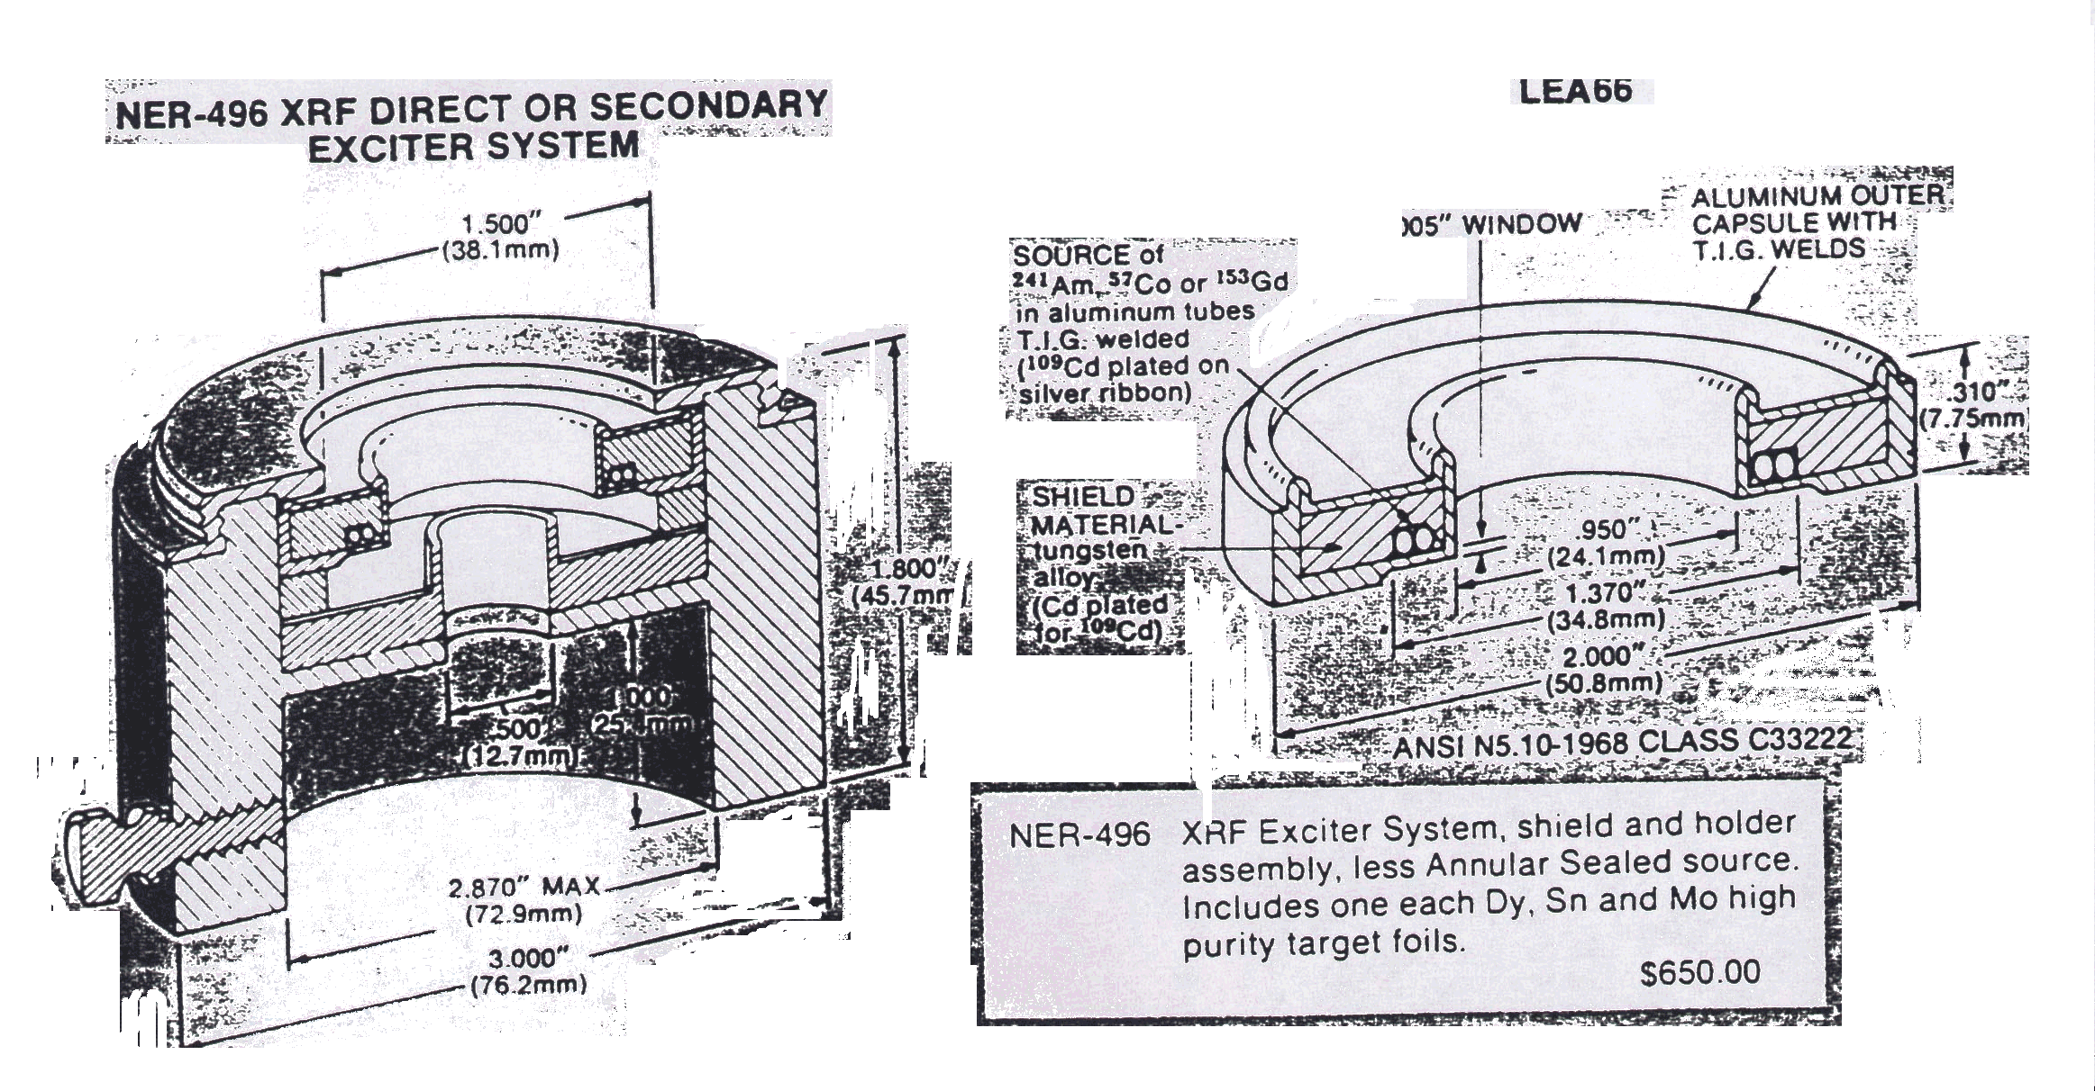
The detector was Princeton Gamma-Tech Ge(Li) model IGP55 lithium-drifted germanium detector. This means it is a germanium wafer with lithium atoms in defects of the crystal lattice. A high voltage power supply (Tennelec, model TC 945) provides a –1500V across the wafer, which is of type p-i-n. An incident x-rays collides with an electron in the valance band of the semi-conductor and raises it the conduction band. The high-voltage bias allows that electron to collide with other conduction electrons and a cascade effect results. These charge carriers are removed from the depletion region and collected. The total charge collected is proportional to the energy of the original photon. The energy range of the detector appeared to be about 4keV to 35 keV because lines outside this range were not observed while lines of the same element within the range were seen. The spectroscopy amplifier gain was optimized for this range.
A charge-sensitive pre-amplifier (Princeton Gamma-Tech model PO-12B) was attached directly to the detector to reduce the errors from radio-frequency noise and ground loops. This also allows the detector to operate at liquid nitrogen temperature, which reduces thermal noise. The output of the pre-amplifier produces a sawtooth wave whose height and frequency indicate the photon energy. A procedure for checking and turning on the system is cover in the instruction manual[1]. This procedure calls for checking the pre-amplifer voltage with a bias of -50 to -100 volts and then raising it to –1500 volts and was followed carefully. The frequency of the sawtooth was approximately 30 Hz after several minutes indicating an excessive leakage current. It was later shown that raising the high voltage basis at the indicated rate of “less than one hundred volts per second” was too fast. One must instead raise the voltage in approximately 50 volt increments while watching the frequency of the sawtooth on the oscilloscope and allowing it to return to less than the 10 Hz limit after each voltage increment. This allows the charge carriers time to leave the depletion region and the semi-conductor to be truly intrinsic.
The output of the pre-amplifier goes to the input of a spectroscopy amplifier (Ortec, model 472) which digitizes the signal and then it is sent into a multi-channel analyzer (Tennelec/Oxford PCA Multiport Multichannel Analyzer). The settings for the spectroscopy amplifier are as follows: gain=200, shaping constant=6.0 μsec, polar=positive, BLD=Lo, and delay=IN. The Ortec model 472 also produces the power for the pre-amplifier, which is connected with 9-pin cable. From the unipolar output, the signal goes to the ADC-IN coax port on the back of the multichannel analyzer. No signal was seen and dead time went to 100% on the MCA when the unipolar output went to the ADC IN on the front of the MCA. The inhibit out of the pre-amplifier was connected to the Gate coax jack on the back of the MCA. From the MCA the signal is sent to a Macintosh computer via a SCSI cable for display and analysis.
With the exception of the “gain”, “display”, and “anti-coincidence” settings the software setting did not need to be changed from their defaults. The software “gain” and “display” were set to 4096 and the anti-coincidence was turned on to prevent simultaneous events from being counted [4].
ANALYSIS OF DATA

The Oxford PCA MCA software provided an option for a “Peak Search”. This was used to identify peaks with a Gaussian profile and a report was generated for samples. With this report and raw data, the analysis was moved to Microsoft Excel.
A calibration was needed to relate channel number to energy. This relationship is linear. Eight peaks were used to create a linear fit for energy as a linear function of channel number. Some discrimination was required to determine which peaks were which transitions of which elements. In addition to the YBCO superconductor (which contains Yttrium (Y), Barium (Ba), Copper (Cu), and Oxygen (O)), samples of Y₂O₃, Copper, and background samples helped guide the process. For example, Y lines would be strong in both YBCO and Y₂O₃, but no others. The brightest (greatest counts per second) are generally K_{α} lines while K_{β} lines are next. See Table 1 and Graph 1 for calibration data and linear fit.

Table 1: First YBCO Calibration Data (all energies in keV)
Channel | FWHM Channel | Line | Measured Energy | FWHM Energy | AcceptedEnergy | Difference  in E | % diff
313.03 | 20 | Unknown | 5.341968 | 0.312 | ? | ? | ?
506.3 | 16.24 | Cu K_{α} | 8.35698 | 0.253344 | 8.047 | 0.30998 | 3.709235
612.41 | 9.52 | W L_{β} | 10.0123 | 0.148512 | 9.959 | 0.053296 | 0.532305
951.14 | 19.08 | Y K_{α} | 15.29648 | 0.297648 | 14.957 | 0.339484 | 2.21936
1067.47 | 21.76 | Y K_{β} | 17.11123 | 0.339456 | 16.736 | 0.375232 | 2.192899
1360.98 | 11.97 | Ag K_{α} | 21.68999 | 0.186732 | 22.162 | 0.472012 | 2.176175
1415.59 | 21.19 | Cd K_{α} | 22.5419 | 0.330564 | 23.172 | 0.630096 | 2.795221
1596.52 | 13.58 | Cd K_{β} | 25.36441 | 0.211848 | 26.093 | 0.728588 | 2.872481
2064.94 | 13.81 | Ba K_{α} | 32.67176 | 0.215436 | 32.191 | 0.480764 | 1.471497
2333.17 | 12.92 | Ba K_{β} | 36.85615 | 0.201552 | 36.376 | 0.480152 | 1.302773

In the YBCO sample all lines were accounted for with one exception. A line appearing at 5.34 keV showed up in all YBCO samples and Y₂O₃, but no other samples. Additionally, the intensity scaled proportional to Y K_{α} and Y K_{β} lines in all three samples containing Y to within five percent. It would seem the 5.3 keV line belongs to Y. However the closest Y line is 2.4 keV. Vanadium or chromium have lines within the error range. Our only explanation is that one of these elements contaminated the Y samples in proportion to the amount of Y present. Nevertheless this line was omitted from the calibration. Interestingly the calibration was apparently valid for this energy range (4-8 keV) because lines of Ti, V₂O₃, HgCl₂, and SrCl₂ were successfully matched with there accepted values.
The calibration function was applied to the other samples to identify the peaks and the results are shown in the attached appendix. Steel was found to contain iron and nickel, a nickel coin was found to contain nickel and zinc, and matches did not contain any lines above the ~4 keV lower bound, thus indicating they contained no significant amounts of any element with Z lower than 20, or calcium.
DISCUSSION OF ERRORS

According to the Princeton Gamma-Tech Ge(Li) Handbook[2] the overall system resolution is related to the detector resolution and electronic resolution by
$σ_{\text{system}}=\sqrt{σ_{\text{det}\text{ector}}^{2}+σ_{\text{electronics}}^{2}}$.
The detector resolution is given by
$$σ_{\text{det}\text{ector}}=1\text{.}\text{44}\sqrt{E}$$
where σ_{detector} is in keV and E is in MeV. If we take E to be the largest energy encountered of 30 keV=0.03MeV, then the detector resolution is 0.249 keV. Estimating the electronics contribution to the system resolution is more difficult. However few of the full-width-half-maximum’s of the lines exceeded 0.3 keV, so it is reasonable to conclude the detector resolution dominates the error. Since lines were only assigned if the energy was within the FWHM, we can say the overall system resolution is 0.3 keV.
Thermal noise can be shown to be small. Knowing that the detector temperature was 77K and the bandgap of the detector is 2.9 eV, we can calculate the probability that an electron is thermally excited in the conduction band by
$$P=e^{{−E_{g}}/{\text{kT}}}=e^{−2\text{.}9{\text{eV}}/(8\text{.}6⋅{\text{10}}^{−5}{\text{eV}}/K∗\text{77}K)}{\text{10}}^{−\text{191}}\text{.}$$
Needless to say, thermal excitations did not significantly contribute to the error.
Since a finite number of counts were observed, any given peak will have some shot noise associated with it. The ratio of noise to peak height will be approximately (N)^{-1/2}, where N is the number of counts in a given peak[3]. To find the typical case contribution, use the typical observed energy (15 keV) and a typical number of counts (75). In this case shot noise contributes as
$$σ_{\text{shot}}=E⋅\frac{1}{\sqrt{N_{\text{typical}}}}=\text{15}\text{keV}⋅\frac{1}{\sqrt{\text{75}}}=1\text{.}7\text{keV}\text{.}$$
Clearly shot noise introduces significant error. The easiest way to reduce this would have been to allow the experiment to integrate over a much longer time period, instead of the five minutes we used. To reduce the shot noise by a factor of five to bring it within the acceptable range (~0.3keV), 2500 counts would required for a 15 keV line. That means integrating for a time thirty times longer than we did, or two and a half hours. This may heat the detector and a greater thermal drift may occur. The alternative would be to get a stronger source, or only study the brightest lines. This error estimate is probably too high, only peaks with a percent error (from the peak search) less than ten percent were taken. This discrepancy remains to be explained. The linear fit also introduces error, but the R² value indicates they are less than one percent.
Trials were preformed on the same day within two hours of one another. Nevertheless the x-rays and currents could have heated the detector, or the liquid nitrogen could have continued to cool it. To examine this thermal drift samples with YBCO were performed at the beginning and end of the run. As seen in Table 2, the differences are well within the system’s resolution of 0.3 keV and thermal drift may therefore be ignored.

Table 2: Comparison of Changes in Energy Before and After Experiment
(energies in keV)
Line | First Trial | Second Trial | Difference
Cu K_{a} | 8.35698 | 8.36166 | -0.00468
W L_{b} | 10.0123 | 10.01479 | -0.0025
Y K_{a} | 15.29648 | 15.2943 | 0.002184
Y K_{b} | 17.11123 | 17.11076 | 0.000468
Cd K_{a} | 22.5419 | 22.53176 | 0.01014
Cd K_{b} | 25.36441 | 25.32994 | 0.034476
Ba K_{a} | 32.67176 | 32.68081 | -0.00905
Ba K_{b} | 36.85615 | 37.77905 | -0.9229

CONCLUSIONS

The approximate system resolution of 0.3keV allowed at least one and usually two characteristic lines of all twelve of the samples to be resolved and a positive identification made. This proves x-ray fluorescence with our equipment to be a useful tool for identifying elements with atomic number Z between about twenty and eighty. Despite this success there are unresolved issues. Foremost, allowing the system to integrate until all lines of interest had at least a thousand or more counts could substantially reduce shot noise, although it is unclear exactly how much it contributes to overall error. Secondly, the 5.4 keV line in Yttrium we observed still remains to be explained.

REFERENCES

[1] Intrinsic Germanium Instruction Manual. Princeton Gamma-Tech. Princeton, NJ. 1980.

[2] Ge(Li) Handbook, Third Ed. Princeton Gamma-Tech. Princeton, NJ. 1970.

[3] Philip Bevington and D. Keith Robinson. Data Reduction and Error Analysis for the Physical Sciences. McGraw-Hill. 1992.

[4] Instruction Manual: PCA-Multiport. Oxford Instruments Inc. 1992.

APPENDIX: Raw Data

Table 3: Peak Report for First YBCO Trial

Channel | FWHM  Of Channel | Line | Experimental Energy | FWHM of Energy | AcceptedEnergy | Difference in Energy | % Difference
313.03 | 20 | Y L? | 5.341968 | 0.312 | ? | ? | ?
506.3 | 16.24 | Cu K_{α} | 8.35698 | 0.253344 | 8.047 | 0.30998 | 3.709235
612.41 | 9.52 | W L_{β} | 10.0123 | 0.148512 | 9.959 | 0.053296 | 0.532305
951.14 | 19.08 | Y K_{α} | 15.29648 | 0.297648 | 14.957 | 0.339484 | 2.21936
1067.47 | 21.76 | Y K_{β} | 17.11123 | 0.339456 | 16.736 | 0.375232 | 2.192899
1360.98 | 11.97 | Ag K_{α} | 21.68999 | 0.186732 | 22.162 | 0.472012 | 2.176175
1415.59 | 21.19 | Cd K_{α} | 22.5419 | 0.330564 | 23.172 | 0.630096 | 2.795221
1596.52 | 13.58 | Cd K_{β} | 25.36441 | 0.211848 | 26.093 | 0.728588 | 2.872481
2064.94 | 13.81 | Ba K_{α} | 32.67176 | 0.215436 | 32.191 | 0.480764 | 1.471497
2333.17 | 12.92 | Ba K_{b} | 36.85615 | 0.201552 | 36.376 | 0.480152 | 1.302773

Table 4: Peak Report for Copper

Channel | FWHM Channel | Line | Experimental Energy | Accepted Energy | % Deviation
475.67 | 20.11 | Cu K_{α} | 7.879152 | 8.047 | 2.13028
563.02 | 16.34 | Cu K_{β} | 9.241812 | 8.904 | 3.655257
618.32 | 31.53 | Zn K_{β} | 10.10449 | 9.571 | 5.279751
1413.2 | 20.53 | Cd K_{α} | 22.50462 | 23.172 | 2.965524
1595.34 | 11.93 | Cd K_{β} | 25.346 | 26.093 | 2.947194

Table 5: Peak Report for MoO₃

Channel | FWHM Channel | Line | Experimental Energy | Accepted Energy | % Error
403.9 | 14.47 | Co Kα | 6.75954 | 6.93 | 2.521769
475.67 | 20.11 | Co K_{ab} | 7.879152 | 7.709 | 2.159522
618.32 | 31.53 | W L_{β} | 10.10449 | 9.67 | 4.299989
1113.45 | 21.6 | Mo K_{α} | 17.82852 | 17.478 | 1.966063
1252.88 | 21.48 | MoK_{ab} | 20.00363 | 20.002 | 0.008139
1413.2 | 20.53 | Cd K_{α} | 22.50462 | 23.172 | 2.965524
1595.34 | 11.93 | Cd K_{β} | 25.346 | 26.093 | 2.947194

Table 6: Peak Report for CoCl₂

Channel | FWHM Channel | Line | Experimental Energy | AcceptedEnergy | %Error
433.67 | 17.73 | Co K_{α} | 7.223952 | 6.93 | 4.06913
480.44 | 15.8 | Co K_{β} | 7.953564 | 7.649 | 3.829277
1115.73 | 17.37 | Y K_{ab} | 17.86409 | 17.037 | 4.629892
1415.39 | 18.68 | Cd K_{α} | 22.53878 | 23.172 | 2.809451
1596.18 | 19.99 | Cd K_{β} | 25.35911 | 26.093 | 2.893998

Table 7: Peak Report for K₄Fe(CN)₆

Channel | FWHM Channel | Line | Experimental Energy | Accepted Energy | % Error
399.17 | 16.23 | Fe K_{α} | 6.685752 | 6.403 | 4.229173
529.31 | 16.65 | Zn K_{α} | 8.715936 | 8.638 | 0.894178
613.15 | 23.69 | W L_{β} | 10.02384 | 9.959 | 0.646858
1415.76 | 19.28 | Cd K_{α} | 22.54456 | 23.172 | 2.783129
1595.53 | 20.58 | Cd K_{β} | 25.34897 | 26.093 | 2.935157

Table 8: Peak Report for Y₂O₃

Channel | FWHM Channel | Line | Experimental Energy | Accepted Energy | % Error
242.19 | 17.31 | Ti K_{α} | 4.236864 | 4.504 | 6.305041
313.62 | 18.21 | ? | 5.351172 | ? | ?
429.97 | 16.24 | Fe K_{ab} | 7.166232 | 7.111 | 0.770726
529.17 | 16.85 | Zn K_{α} | 8.713752 | 8.638 | 0.869338
613.33 | 26.09 | W L_{β} | 10.02665 | 9.959 | 0.674682
951.17 | 19.78 | Y K_{α} | 15.29695 | 14.957 | 2.222351
1067.95 | 21.25 | Y K_{β} | 17.11872 | 16.736 | 2.235681
1414.69 | 18.57 | Cd K_{α} | 22.52786 | 23.172 | 2.859286
1597.66 | 16.81 | Cd K_{β} | 25.3822 | 26.093 | 2.800404

Table 9: Peak Report for HgCl₂

Channel | FWHM Channel | Line | Experimental Energy | Accepted Energy | % Error
114.6 | 15.44 | S K_{α} | 2.24646 | 2.308 | 2.739421
243.03 | 5.78 | Ti K_{α} | 4.249968 | 4.504 | 5.977269
530.62 | 6.04 | Zn K_{α} | 8.736372 | 8.638 | 1.126005
631.18 | 19.61 | Hg L_{α} | 10.30511 | 9.987 | 3.086896
752.38 | 23.4 | Hg L_{IIIab} | 12.19583 | 12.285 | 0.731168
878.48 | 13.51 | Hg L_{IIab} | 14.16299 | 14.212 | 0.346057
1415.68 | 20.58 | Cd K_{α} | 22.54331 | 23.172 | 2.788819
1596.99 | 8.3 | Cd K_{β} | 25.37174 | 26.093 | 2.842753

Table 10: Peak Report for V₂O₅

Channel | FWHM  Channel | Line | Experimental Energy | Accept Energy | % Error
306.12 | 15.05 | V K_{α} | 5.234172 | 4.952 | 5.390958
339.82 | 15.3 | V K_{β} | 5.759892 | 5.427 | 5.779483
528.75 | 17.42 | Zn K_{α} | 8.7072 | 8.638 | 0.794745
615.61 | 32.74 | W L_{β} | 10.06222 | 9.959 | 1.025778
753.71 | 16.31 | Hg L_{IIIab} | 12.21658 | 12.285 | 0.560091
1113.66 | 17.3 | Mo K_{α} | 17.8318 | 17.478 | 1.984074
1414.46 | 20.94 | Cd K_{α} | 22.52428 | 23.172 | 2.875671
1595.68 | 11.31 | Cd K_{β} | 25.35131 | 26.093 | 2.925656

Table 11: Peak Report for Steel

Channel | FWHM  Channel | Line | Experimental Energy | AcceptedEnergy | % Errror
399.87 | 17.25 | Fe K_{ab} | 6.696672 | 7.111 | 6.187073
441.93 | 14.5 | Ni K_{α} | 7.352808 | 7.477 | 1.689042
1415.33 | 23.16 | Cd K_{α} | 22.53785 | 23.172 | 2.81372

Table 12: Peak Report for Background

Channel | FWHM Channel | Line | Experimental Energy | Accepted Energy | % Error
469.05 | 13.61 | Co K_{ab} | 7.77588 | 7.709 | 0.860096
528.91 | 19.03 | Zn K_{α} | 8.709696 | 8.638 | 0.823175
612.65 | 23.33 | W L_{β} | 10.01604 | 9.959 | 0.569487
717.52 | 17 | W L_{IIab} | 11.65201 | 11.535 | 1.004221
1415 | 23.92 | Cd K_{α} | 22.5327 | 23.172 | 2.83721
1596.72 | 15.3 | Cd K_{β} | 25.36753 | 26.093 | 2.859829

Table 13: Peak Report for Second YBCO Trial

Channel | FWHM Channel | Line | Experimental Energy | AcceptedEnergy | % Error
313 | 19.16 | ? | 5.3415 | ? | ?
506.6 | 15.38 | Cu K_{α} | 8.36166 | 8.047 | 3.763128
612.57 | 21.92 | W L_{β} | 10.01479 | 9.959 | 0.557096
951 | 20.25 | Y K_{α} | 15.2943 | 14.957 | 2.205397
1067.44 | 19.48 | Y K_{β} | 17.11076 | 16.736 | 2.190224
1414.94 | 20.35 | Cd K_{α} | 22.53176 | 23.172 | 2.841482
1594.31 | 7.57 | Cd K_{β} | 25.32994 | 26.093 | 3.012499
2065.52 | 14.31 | Ba K_{α} | 32.68081 | 32.191 | 1.498775
2392.33 | 10.67 | Ba K_{β} | 37.77905 | 36.376 | 3.713826

Table 14: Peak Report for Nickel Coin

Channel | FWHM Channel | Line | Experimental Energy | AcceptedEnergy | % Error
469.17 | 15.45 | Ni K_{α} | 7.777752 | 7.477 | 3.866824
505.24 | 14.3 | Ni K_{β} | 8.340444 | 8.264 | 0.916546
530.71 | 10.99 | Zn K_{α} | 8.737776 | 8.638 | 1.141892
563.47 | 7.65 | Zn K_{β} | 9.248832 | 9.571 | 3.483337
612.77 | 23.7 | W L_{β} | 10.01791 | 9.959 | 0.588067
1414.79 | 24.37 | Cd K_{α} | 22.52942 | 23.172 | 2.852163
1595.96 | 5.87 | Cd K_{β} | 25.35568 | 26.093 | 2.907925

Table 15: Peak Report for Matches

Channel | FWHM Channel | Line | Experimental Energy | Accepted Energy | % Error
528.68 | 17.08 | Zn K_{α} | 8.706108 | 8.638 | 0.782301
613.4 | 24.75 | W L_{β} | 10.02774 | 9.959 | 0.685498
714.26 | 8.82 | W L_{IIab} | 11.60116 | 11.535 | 0.570254
1359.56 | 29.67 | Ag K_{α} | 21.66784 | 22.162 | 2.280634
1414.3 | 24.36 | Cd K_{α} | 22.52178 | 23.172 | 2.887072
1602.92 | 14.8 | Cd K_{β} | 25.46425 | 26.093 | 2.46914

