Quantum Scattering and a Determination of
The Scattering Cross-Section of
Xenon Gas in a 2D21 Thyratron Tube

Abstract
In the Ramsauer-Townsend experiment we utilized very basic equipment to observe the scattering effects of low-energy electrons from xenon atoms. The phenomenon being investigated was the behavior of the scattering cross-section as a function of the bombarding electron’s energy. The results obtained showed that the drastic decrease in the cross-section occurred when the electrons had an energy of 0.6965 electron-volts. The classical description of this phenomenon does not allow for this observed drop in the cross-section. This leads to the unavoidable conclusion that electrons must have a wave nature which is responsible for the classically unexpected scattering phenomenon.

Introduction
By this point in one’s life, it should be well established that the classical theory of physics is not adequate for describing all physical phenomenon. In particular it lacks the ability to predict atomic-scale events.
The Ramsauer-Townsend experiment was performed first in the early 1920’s. The results obtained were clearly non-classical. It was observed that as a bombarding electron’s velocity increased, the scattering cross-section of the heavy rare gas with which it was colliding did not decrease monotonically as expected, but rather it passed through an extremum at some critical velocity. This effect can not be explained by the classical picture of particle collisions. It is from this experiment that clear evidence for the wave aspect of electrons was be obtained.

Theory
The theory of the Ramsauer-Townsend effect is seeded deep into the wave-nature
of matter. It is a scattering phenomenon in which one deals with the probability of a collision occurring. The theory of atomic scattering is arrived at via the Schrödinger Wave equation. This equation is the heart of the quantum theory of mechanics and is used to describe the motion of particles on the atomic level. This equation is a wave
equation (i.e. second-order partial differential equation that has space and time as the independent variables) which must be the case if it is used to obtain wave descriptions for this experiment. The difference between this equation and most other wave equations is that the dependent variable is not intuitively clear. The quantity which I speak of is called the wave function , and is defined in the following way:
$\begin{aligned} \left[ {\left|Ψ\right|}^{2}⋅ΔV \right] \\ \text{is} \text{proportional} \text{to} \text{the} \text{probability} \text{the} \text{electron} \text{will} \text{be} \text{found} \text{in} \text{the} \text{volume} ΔV (1)\end{aligned}$
$\frac{ℏ^{2}}{2m}\frac{d^{2}Ψ}{{\text{dx}}^{2}}=−\left(E−V\right)Ψ (2)$and for a particle moving in one dimension is given by:

which is a second-order ordinary differential equation (here E equals the total energy of the particle, and V is the particle’s potential energy as a function of its position). Equation (2) was introduced with the sole intention of being able to reference it at a later time.
Another quantity known as the collision cross-section or scattering cross
-section is needed to represent the probability for a collision occurring. This cross-section is basically a measure of how large the xenon atoms ‘appear’ to the bombarding electrons. It is used to represent the area of the atom involved in a collision. This is needed because quantum mechanics tells us that atoms are not hard spheres of radius r, therefore πr² is not indicative of the area of an atom. The effective area, or cross-section is also quite obviously not constant. It depends on many factors such as the type of collision, the kinetic energy of the incoming electrons, etc. Any process that removes electrons from a beam would contribute to the measured cross-section. Two conditions we are interested in are elastic collisions with small kinetic energies. The kinetic energy must be small because at low energies, the elastic scattering process dominates.
To arrive at an expression that will allow us to experimentally determine
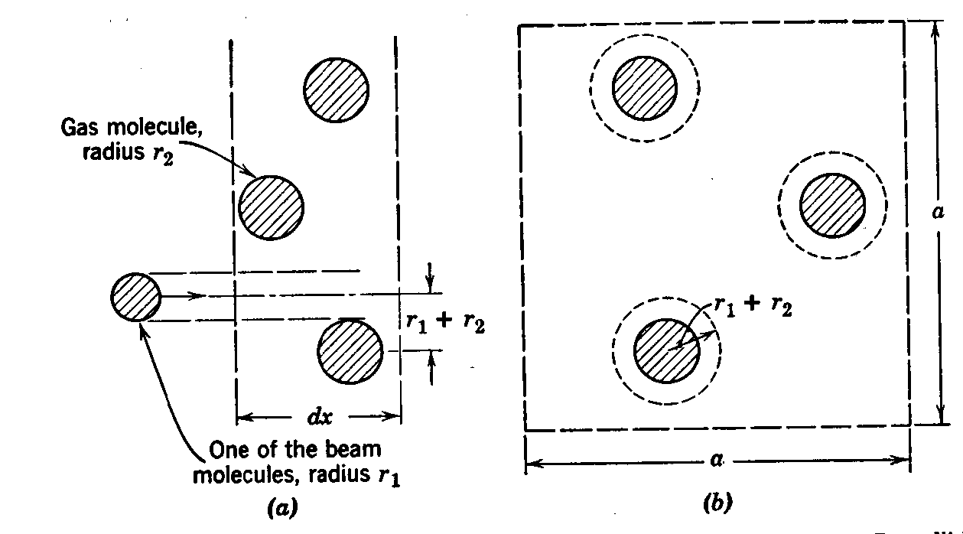
the scattering cross-section, begin by considering a process that removes electrons from a beam of electrons. The process we are interested in is elastic scattering. For generality, consider a beam of particles passing through a gas. Picture a square section of this gas of length ‘a’ and thickness ‘dx’ containing spheres of the gaseous molecules (see picture (b)). The radii of the beam particle and the gaseous molecule are r₁ and r₂, respectively. A collision will occur if the center of the beam particle passes within (r₁+r₂) of the center of the molecule. The number of molecules in an area ‘a²’ is given by the product of N (the number per unit volume) and a² dx (the volume of the sheet of thickness
dx)(see picture above)

The total area enclosed in all the dotted circles (in above picture) is
Nπ(r₁+r₂)²a² dx, and the total area is a². The fraction of the area enclosed in the dotted circles is Nπ(r₁+r₂)² dx. Each point in the square has an equal probability of being struck by a beam particle, so the fraction of beam particles which collide in a distance dx is just equal to this area fraction. Every beam particle that collides can be thought of as being removed entirely from the incident beam. This causes a reduction in the current density J (beam particles/m²sec) by an amount dJ. In travelling a distance dx, the fraction of $\frac{\text{dJ}}{J}=−Nπ{\left(r_{1}+r_{2}\right)}^{2}\text{dx} (3)$removed from the beam is:
In order to use this expression experimentally, it can be integrated to find the
$\begin{aligned}\int{\frac{\text{dJ}}{J}}=−Nπ{\left(r_{1}+r_{2}\right)}^{2}\int{\text{dx}} \\ \\ J=J_{0}e^{−Nπ(r_{1}+r_{2})^{2}x} (4)\end{aligned}$magnitude of the current density:
In this expression J₀ represents the magnitude of the current density at x = 0, and the quantity π(r₁+r₂)² is known as the scattering cross section. This expression explicitly shows that the particle beam is attenuated exponentially as it passes through the gas, and this attenuation depends on the size of the gas molecules. In the Ramsauer-Townsend experiment, J₀ is found from the plate and shield currents at the frozen-out temperatures.
This derivation has been performed with the idea that the particles
$\begin{aligned}\text{dJ}=−\text{JN}{\left({πr}_{2}\right)}^{2}\text{dx} \\ \\ J=J_{0}e^{−{Nπr}_{2}^{2}x} {\text{electrons}}/{m^{2}}\text{sec} (5)\end{aligned}$ involved in the collision can be treated as hard spheres, and whenever their centers are separated by a distance (r₁+r₂), a collision occurs. This is by no means an accurate description of atoms or electrons, and is used only as a way to visualize the occurrences. However this description can be applied to our situation of electron-atom collisions if we set r₁ = electron’s radius equal to zero, and realize that r₂ is the effective radius (i.e. the radius that hard spheres would require in order to produce the same collision rate as the actual atom). Equation (4) now becomes:

J represents the number of electrons per second per square meter, and the
electrical current density is j = eJ. Recall that N is the number of gas atoms per cubic meter, x is the distance in the direction of motion of the beam, and we can replace (πr₂²) by the equivalent symbol σ, which represents the atoms scattering cross-section. The attenuation of the beam can then be written:
$j=\text{eJ}=j_{0}e^{−Nσx} {\text{amp}}/{m^{2}} (6)$
This now allows one to experimentally determine the scattering cross-section σ by observing the decrease in j with the distance traversed.
$\begin{aligned}J_{p}=J_{0}e^{−l({Nπr}^{2})} \\ J_{p}=J_{0}(1−P_{s}) (7)\end{aligned}$ In the Ramsauer-Townsend experiment, an electron beam originates from a cathode in the first section of the apparatus. The thermionically produced beam of electrons passes through the second section where some of the electrons are scattered by the xenon atoms and collected on the shield and the rest are collected on the plate that is located in the third section. The beam intensity at the plate is given by equation (5). If the plate is located a distance l from the first aperture (i.e. point of separation between the 1st and 2nd sections), then the intensity at the plate is:
$I_{p}=I_{s}f(V)(1−P_{s}) (8)$In the second expression given for J_{s}, P_{s} represents the probability of scattering. The plate current is then given by:
where I_{s} is the shield current and f(V) is a geometrical factor which contains the ratio for the angle intercepted by the plate to the angle intercepted by the shield and a factor due to space charge effects near the cathode (note: space charge is the effect that occurs because thermionically emitted electrons form a negative sheath in the vicinity of the cathode and thereby inhibit further emission). To measure f(V), the xenon is frozen out with liquid nitrogen which has the effect of reducing the probability of scattering (i.e. P_{s} ≈ 0). Now f(V) ≈ I_{p}*/I_{s}* where the * represents the frozen out temperature values. This gives the probability of scattering:
$P_{s}=1−\frac{I_{s}^{}I_{p}}{I_{s}I_{p}^{}} (9)$$P_{s}=1−e^{−l(Nσ)} (\text{10})$The probability is related to the cross-section by:
$σ=\frac{1}{\text{Nl}}\text{ln}\frac{I_{s}I_{p}^{}}{I_{s}I_{p}} (\text{11})$This leads to the expression for the cross-section:
In the specific case we are considering, l = 0.7cm, so we can determine σ up to a multiplicative constant. With this in hand, it is possible to determine experimentally the scattering cross-section of the xenon atoms.
The above derivation gives a method for determining this, but not an explanation as to why at some critical velocity (of the electron) the scattering cross-section drops to approximately zero. Here is where the quantum theory of scattering enters the picture.
The motion of the particles cannot be described by classical orbits due to the Heisenberg Uncertainty Principle. Instead one must use wave packets whose average co-ordinates give the classical orbits. The scattering process must therefore be described by wave functions that are solutions of Schrödinger’s equations (see equation (2) above), rather than by particle trajectories that are solutions of the classical equations of motion.
$λ=\frac{h}{p} (\text{12})$Now that we know that the solutions are wave solutions, I will give an explanation of why a minimum value exists in the scattering cross-section at some critical velocity. Note that this portion of the theory rests on the deBroglie wave hypothesis. This hypothesis asserts that particles have a wavelength associated with them, and it is given by:
where h is Planck’s constant, and p is the momentum of the particle. This translates into a decrease in wavelength as the velocity is increased. With this now at hand, we can see how the cross-section evolves.
The electrons are accelerated by an increasing potential. This means they start with very large wavelengths and proceed to gradually decrease in wavelength throughout the experiment. A nice way to visualize the decrease in the cross-section is to think of a collision in terms of a wave being transmitted through a medium that has a different index of refraction. One knows from wave mechanics that when a wave changes mediums, both transmission and reflection occurs. Before continuing to the climactic end of this discussion however, let me insert an discussion to add to the robust-ness of the theory section.
The potential energy of an electron inside an atom can, to some extent, be
approximated as a square well with a uniform depth V_{0.} Consider a particle moving through a region of an atom with a square potential [i.e. V(x) = 0 for Lx0, and V(x) = -V₀ for Lx0](see picture above). Heavy rare gases fit this approximation well because their outer valence electrons are bound very tightly due to their closed-shell structure.
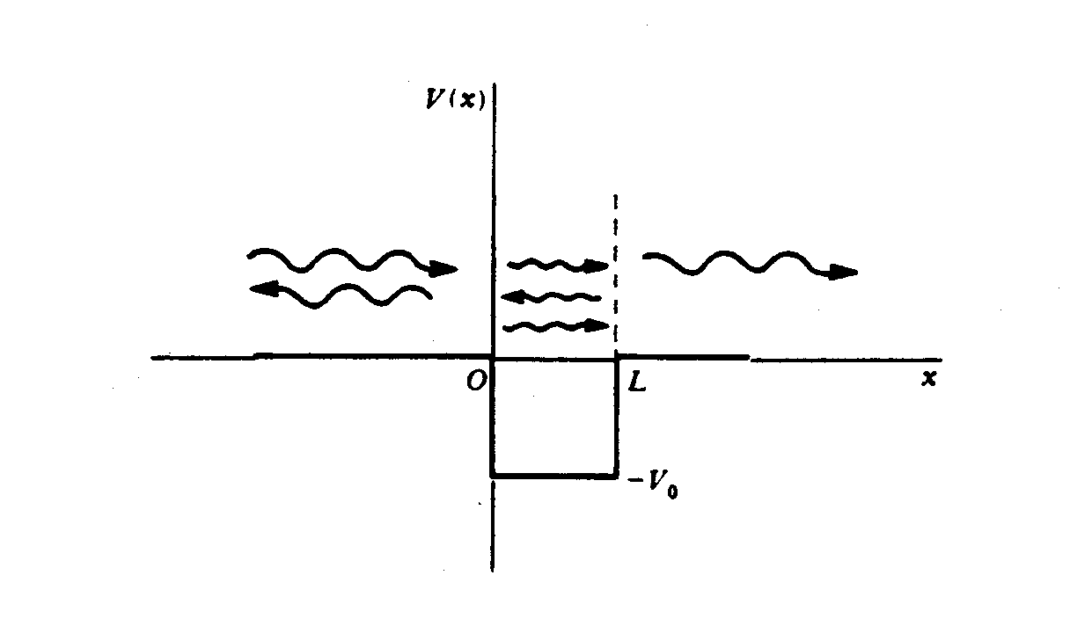
An electron moving from x0 in the positive x-direction will confront the potential well at x = 0. An electron in this situation would, classically, be accelerated as it transversed this region, and would be decelerated as it left this region. It would never reflect from the well because it does not have to overcome some potential at the boundaries of this well.
Quantum mechanically however, this picture is very different. For x = 0 the wavelength of the incident particle changes from λ₁ = h/p₁ = h/√(2mE) to λ₂ = h/p₂ = h/√(2m(E-V₀)). Because of this sudden change which occurs in a distance d  λ, part of the wave is transmitted, and it is partially reflected. The transmitted wave then continues to x = L, where it interacts with a second boundary, and partial transmission and reflection occurs again. Because the particle is governed by the Schrdinger Wave equation (2), the probabilities of transmission and reflection can be calculated. This is achieved by solving the Schrdinger equation in each region in space and then comparing those amplitudes with that of the incident wave. The purpose of performing such a calculation is that it is very similar to optical reflection and transmission.
It is probably quite obvious where this discussion is headed. The next step in this is to see if one could get the wave to reflect at the boundaries to achieve 100% transmission. This occurs when the well size is equal to half of the wavelength of the particle in the well. The wave reflected at x = L travels a half wavelength from x = 0 to x = L, and by the time it reaches x = 0 again it recombines with the new incoming wave to constructively interfere. When this condition is met, there is 100% transmission of the incident wave. This is the Ramsauer-Townsend effect. It can be thought that at v = v₀ where v₀ is the critical velocity, the particle’s wavelength is such that the partial reflections at the ‘beginning’ and the ‘end’ of the atom cancel. The total effect of this is that at the correct velocity, the electron wave fits inside the atom such that the electron effectively does not see the atom, and passes through this region ‘unaffected’.
The interesting effect in this experiment comes from the wave nature of matter
which is basically the electron wave interferes with itself to achieve total transmission.
Apparatus
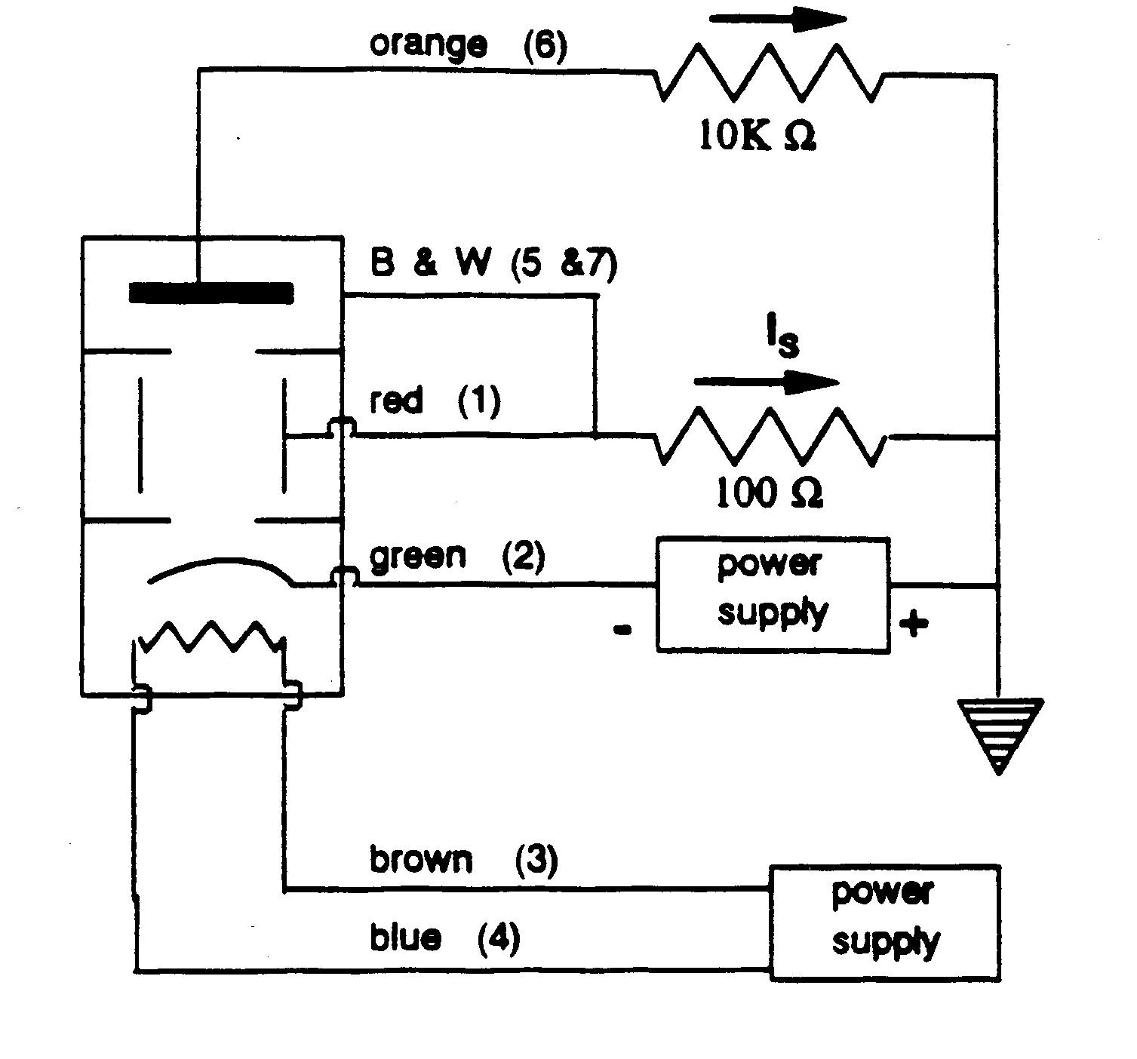

The equipment used in obtaining data was:
- Nobatron – applied a constant potential across the heater inside the thyratron tube.
- 3 Digital Multimeters – used to measure the accelerating potential, the shield potential, and the plate potential.
- Liquid Nitrogen – used to cool the thyratron tube.
- Circuit – used to allow for easier measurements, contained resistors. This circuit is depicted above. The colors are just references to which wires are connected to the thyratron tube.
- Thyratron tube – xenon filled tube shown above. This tube is where all of the experiment occurs. The electrons are thermionically emitted from the cathode, and accelerated into the middle chamber. In this middle chamber is where the electrons suffer collisions with the xenon atoms and are scattered onto the shield. The electrons that are not scattered continue on their path to the plate.

Procedure
The procedure for this experiment was relatively simple. Basically a potential was applied across the thyratron tube. This potential had the affect of accelerating the electrons, that had been thermionically emitted, through the tube. The potential was varied in 100 millivolt increments from 0 to 12.5 volts. For each value of accelerating potential, a value for plate and shield potential were also obtained. The plate potential was a measure of how many electrons made it through the cloud of xenon gas without suffering a collision (it also includes the electrons that collided with the xenon and scattered in the forward direction to be collected by the plate). The shield potential was a measure of the electrons that were scattered by the xenon atoms.
As the accelerating potential was increased, the scattering cross-section increased up to a point. Then it dropped sharply, and resumed climbing shortly after. The reason it drops is due to the Ramsauer-Townsend effect described in the theory section above.
The second portion of the experiment consisted of freezing-out the thyratron tube. We did this by submerging a small portion of the tube in a cup of liquid nitrogen, and then repeating the above procedure. This had the effect of removing the xenon from the tube’s atmosphere, thereby reducing the probability of a collision to approximately zero.
Data Analysis
The data analysis was performed in a somewhat peculiar manner because the method suggested by the references was inadequate for displaying meaningful data. The method indicated by Kukolich was derived in the theory section earlier in this paper and culminated with equation (11) which gives the scattering cross-section as a function of the various currents. This is not accurate for my results because of the terms involving the shield current. When applied to my results, this formula obscures the important results, namely those of electron scattering from xenon atoms, and instead suggests that no-such scattering occurs. This happens because of the way in which the shield current evolves with the acceleration potentials at the different temperatures. It can be seen from the graph of shield potentials versus accelerating potential that at liquid nitrogen temperature, the shield potential does not increase linearly with the acceleration potential $σ=α⋅\text{ln}\left(\frac{I_{s}}{I_{s}^{}}\right) (\text{13})$(see graph next page). This causes a problem when it shows up in equation (11) as:

where α encompasses all the terms not accounted for. The reason it presents a problem is that the ratio of I_{s} to I_{s}* is larger than the ratio involving I_{p}’s. Also the fact that both shield currents do not increase linearly with the accelerating voltage causes a wobble in the graph of the natural log of their ratio(i.e. the equation directly above). This wobble drowns out the plate current contribution to ‘σ’ (this can be seen from graph ln(Is*/Is) and ln(Ip*/Ip) next page), and so the graph of σ_{equiv} v.s. E must be viewed without the shield current contributions (see graph ln(Ip*/Ip)next page).
The energy at which there is 100% transmission is found to be approximately 0.6965 electron volts^{1/2}. This graph was obtained through the amended version for determining the scattering cross-section, discussed above. The important thing about this graph is that it shows that the Ramsauer-Townsend effect was clearly observed. Another graph which clearly shows the quantum effect of electron scattering is the graph of the plate currents at liquid nitrogen temperatures and at room temperature v.s. square root of the potential. If the Ramsauer-Townsend effect was not occurring then one would expect the two graphs to be approximately the same, however it is clear that the graph of the plate current at room temperature deviates tremendously due to the effect. (see graph I(p*) and I(p) v.s. root V_{a} next page).
In a closing note, the data did not reliably display the ionization energy. This is due to a few factors, one of which is the fault of the equipment used in the experiment. At large values of the acceleration potential, a stable reading could not be obtained for the plate or the shield potentials. The experiment was therefore halted at energies of ~12.5 electron volts. The last point taken shows what is apparently ionization. This occurs at an energy of 12.06 electron-volts (see graph V_{s} v.s. V_{accel} next page). The accepted value for the ionization of xenon is 9.45 electron-volts. This leads me to the conclusion that there was a contact potential present that coincides with an energy of 2.61 electron-volts.

Error Analysis
It is useless to talk about the errors in a quantitative way (because of the lack of reliable quantitative data), however I feel it is necessary to give the reader an idea for how my values differ from the accepted values, and also a qualitative feel for what may be responsible for the gross differences.
The accepted value for the dip in the scattering cross-section is 1 electron-volt. Our value which is 0.6965 electron-volts, differs by 30.35%. There are many reasons that this value differs greatly from the expected value. The shear fact that the contributions to the cross-section from the shield current had to be thrown away contribute somewhat, but I think the problem can be solved by considering another quantity which was thrown away. This was the multiplicative constant that involves contributing terms from the length of the thyratron tube and from the space charge effects. The quantity is (1/0.7N) where N is a multiplicative constant. When multiplied by the value obtained for the critical energy (with N = 1), it produces the critical energy of 0.995 electron-volts. This value only differs from the expected value by 0.5%. So it is obvious that the multiplicative constant can determine how precise my results are. Therefore attention should not be focused on the actual values obtained, but more so on the importance of the shape of the data. It is extremely clear that at some critical velocity, the scattering cross-section plummets to zero. That is the most important point in this experiment, because it shows that the effect is occurring, and although some things were thrown away (namely the constants and shield currents), they were not thrown away recklessly.
I thought it should be mentioned that although the results were poor, the experimentation was not. Great care was taken to assure that the data was good. The experiment was repeated twice, and over 250 separate measurements were taken. It is on those grounds that I argue that there was something wrong with some aspect of the experiment (i.e. such as the apparatus, or the method for analyzing). There are only a few other things that I can think of that could have possibly contributed to the error, however these are admittedly far stretches.
As mentioned above, the shield current contribution to the scattering cross-section was discarded because it masked the interesting results. Here I try to explain a possible reason for the masking effect. As can obviously be seen from the graph earlier in the paper of ln(Is*/Is) and ln(Ip*/Ip) versus the root of the accelerating potential, the masking is a result of the ln(Is*/Is) graph having a positive initial slope (concave down)(see graph of ln(Is*/Is) next page). This is opposite of the way in which the ln(Ip*/Ip) graph curves, and so when superimposed on each other, the value for σ in equation (11) gets a smoothed out graph with no dip. I believe the initial curvature of the ln(Is*/Is) graph is an effect of the temperature of the thyratron tube. The tube initially at room temperature, however as the experiment goes on, it heats up to rather high temperatures (due to the potential being applied to it). This would cause an increase in the density of the xenon atoms in the tube’s atmosphere. This would increase the number of collisions later on in the data taking, and it is exactly this that could be responsible for the unexpected curvature.
Another error could be due to the setting of the heater voltage. If not set correctly, space charge effects could become very appreciable. Another possibility could be from the position (on the circuit) from which the values of the acceleration potentials were measured. I noticed while experimenting that the position of the multimeter probes in the circuit (while still measuring the same thing of course) produced different values for the potential drop. I made a plot of the two values to show how one deviated from the other (see graph next page). This deviation was apparently linear, and would only affect the value by a multiplicative constant. The value of the slope was 0.945, so the values of the accelerating voltage, if using the different measurements, would be lower by 5.5%.
Conclusion
The most important result obtained from this experiment, despite all of its shortcomings and amendments, is that after finding a meaningful way to display data, the quantum effects of scattering could be clearly seen. This is evidence for the failure of the classical model which predicts a monotonically decreasing scattering cross-section for an increasing acceleration potential.
These effects were found to be caused by the wave nature of the electrons. When the electrons had an energy such that their wavelength was equal to half the diameter of the xenon atoms, the partial reflections at the two surfaces of the atom acted to constructively interfere with each other. These reflections at the critical energy caused a phase shift of π radians for each leg of the electron’s journey through the atom. Thus in traveling across the atom and back, there is a total phase shift of 2π. This phase shift has no effect on the amplitude of the electron wave, so effectively the electron wave is 100% transmitted.
The value of the electron’s energy at which the Ramsauer-Townsend effect occurred was experimentally determined to be 0.6965 electron-volts. This is not in good agreement with the conventionally accepted value of the critical energy which is ~1.0 electron-volt.

